**Result Automation**

**- Working Model and Appendix**

**Project Done by:**

[**K M S Varun**](https://www.linkedin.com/in/mohan-sai-varun-kasarla-664b91185/)**,** [**K V Kalyan**](https://www.linkedin.com/in/kotichintala-venkata-kalyan-5782a5198/) **(May, 2020 to Aug, 2020)**

17B81A0571, 17B81A0582

Department of CSE,

Students at Sir C R Reddy College of Engg,

Eluru.

**Prerequisites :**

1. **Software Requirements:**

* Windows 7 or better
* Python Installed
* Chrome Installed
* Latest Chrome Driver
* Selenium Installed ( “pip install selenium” )
* XlsxWriter Installed ( “pip install xlsxwriter” )
* Requests Installed ( “pip install requests” )

1. **Hardware Requirements:**

* Intel Dual Core or better
* 2 GB RAM ( Minimum )
* 50 GB HDD or better

**Project Description :**

Result Automation was designed to automate the B. Tech results by JNTU Kakinada. It will require only your Registered Roll Number and the URL for the Result Fetching and it’ll display the result in front of your eyes in seconds in an Automated Way. So that there’s a Dashboard to search for a Single Student or for Multiple Students.

* For Single Student, It’ll automate Google Chrome by chromedriver and Selenium and then fetch the result in the given URL and displays along with the SGPA calculated.
* For Multiple Students, It’ll ask for the Roll Numbers Range so that it can fetch the results for those who fall under the given Range of Roll Numbers and performs the same task for each individual and displays one at a time. Users can also save the fetched result as an Excel File or as a PDF File.

Note: Fetching can be done in both the ways i.e. From Browser and from a PDF File provided.

* Chrome Driver has to be **updated** for the latest version of Google Chrome
* URL is: <https://jntukresults.edu.in/view-results-56736077.html> (Kindly copy this Link and Proceed with the Project.)
* GitHub Link for Project is: <https://github.com/mohansaivarun/Result-Automation>

**Working Model:**

The below are the ScreenShots of the Execution of the Result Automation.

1. This is Our Home Page designed for Our Counsellors

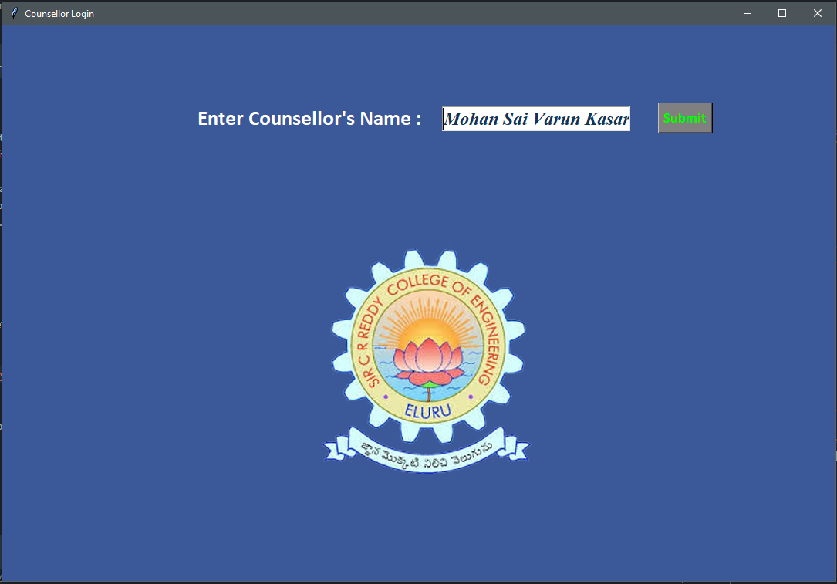

1. This is the User's Dashboard where he/she can fetch the result(s) of Individual or for Multiple Students.

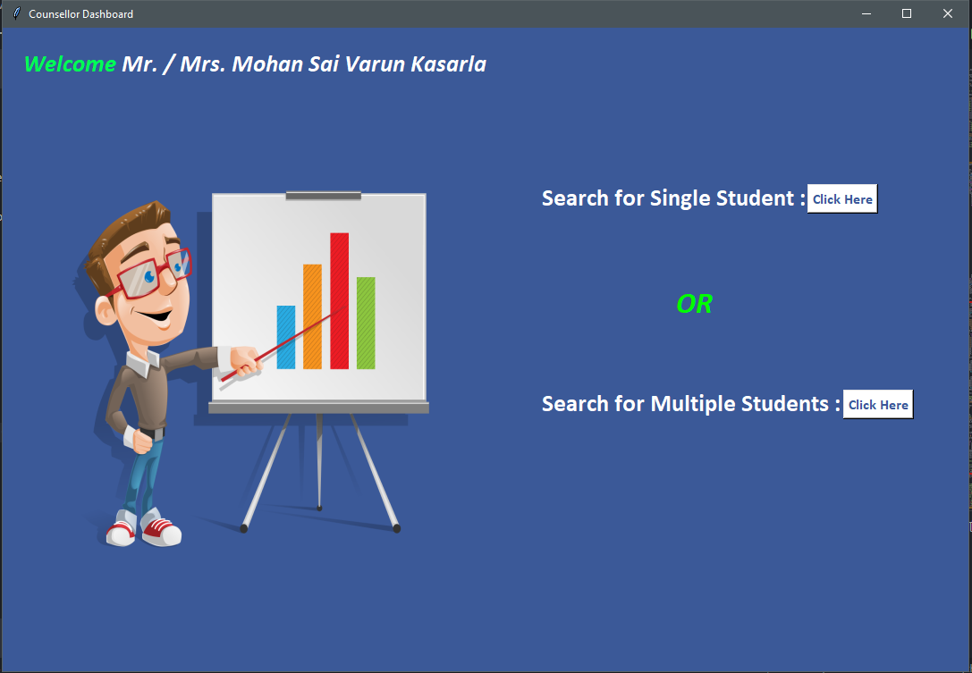

1. This is the Result Fetching Page for Single Student

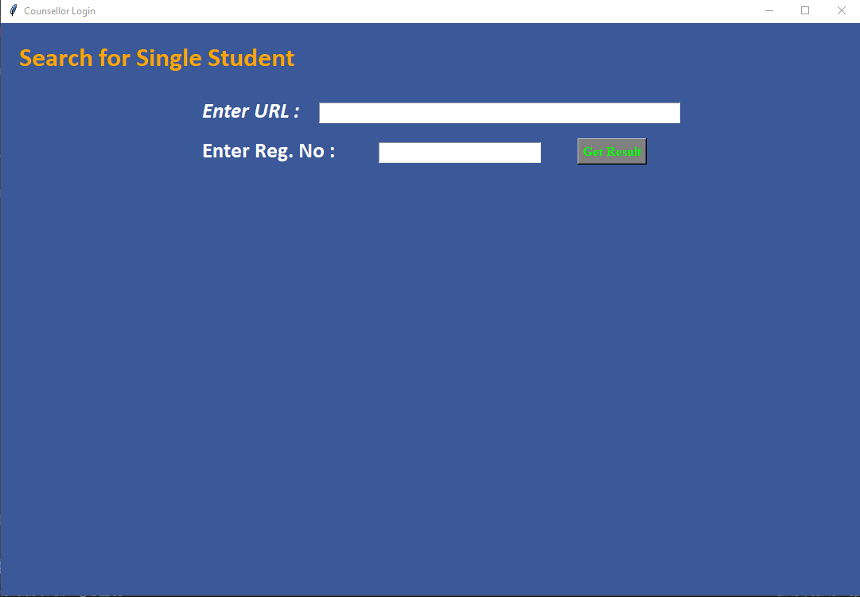

1. This is the Result Fetching Page for Single Student in Browser (i.e. Opening URL)

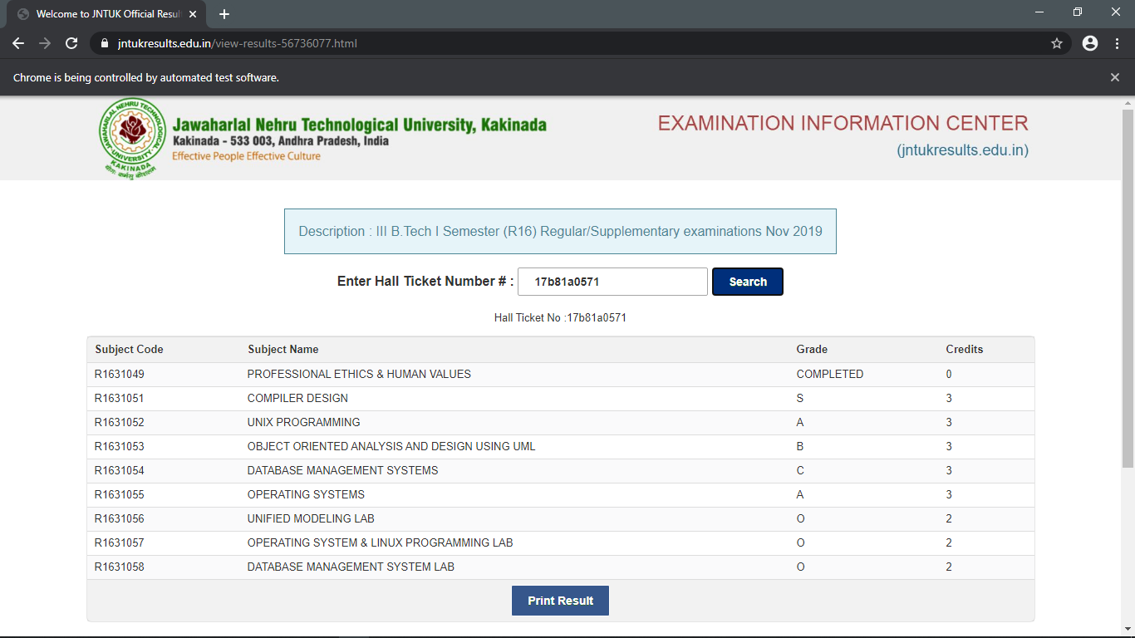

1. This is Dashboard that displays the fetched Result from the Browser along with SGPA Calculated.

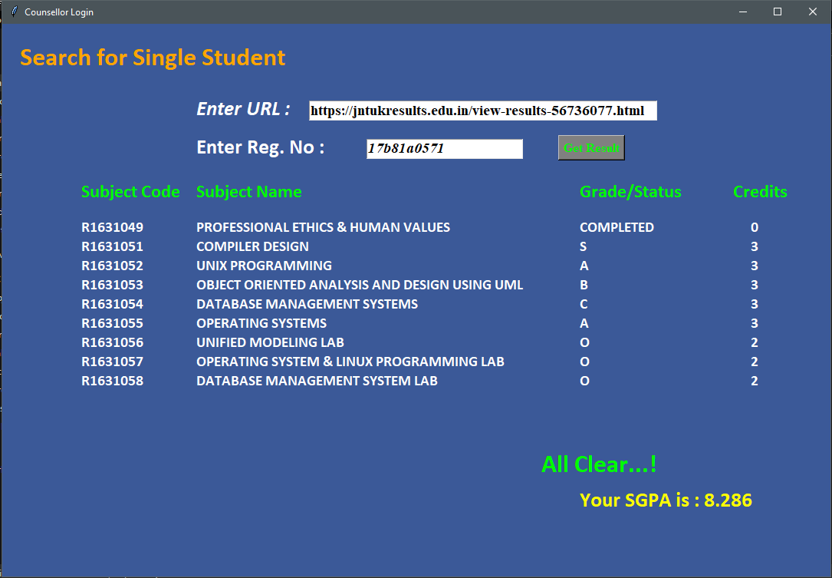

1. This is the Multiple Student Result Fetching Dashboard and it has two options. They’re From PDF and From Browser.

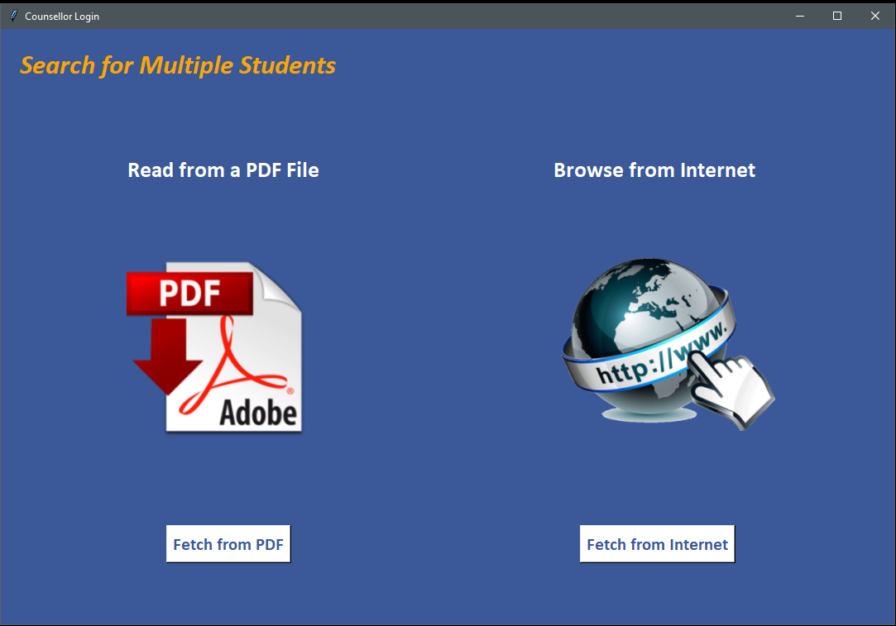

1. These are the screenshots of Fetched Results of Multiple Students.

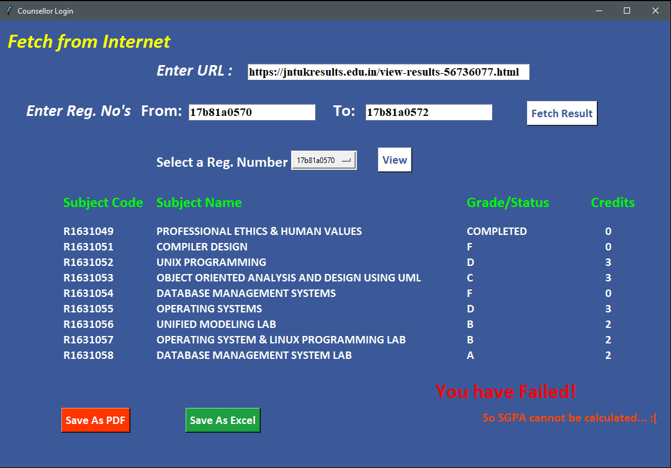

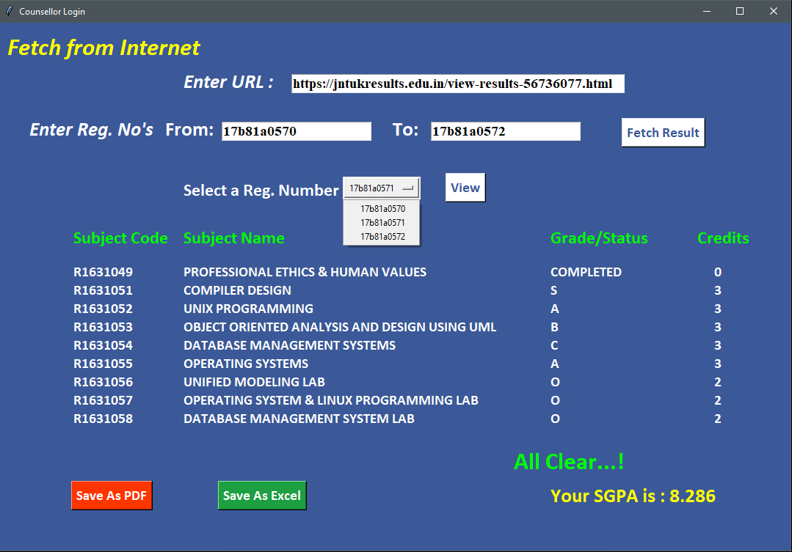

1. These are the screenshots of saving the fetched results of multiple students in Excel File.

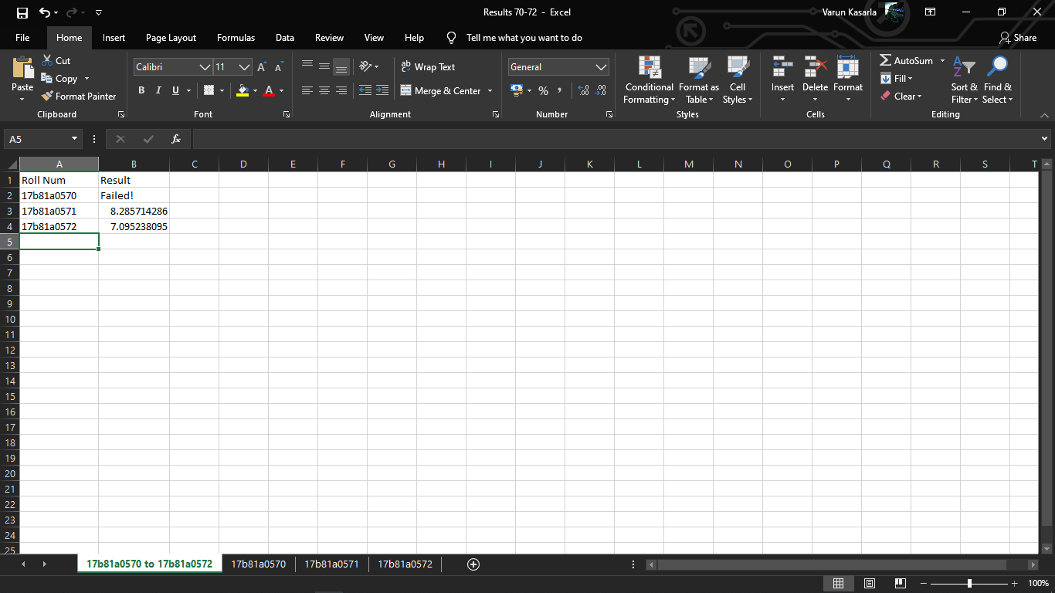

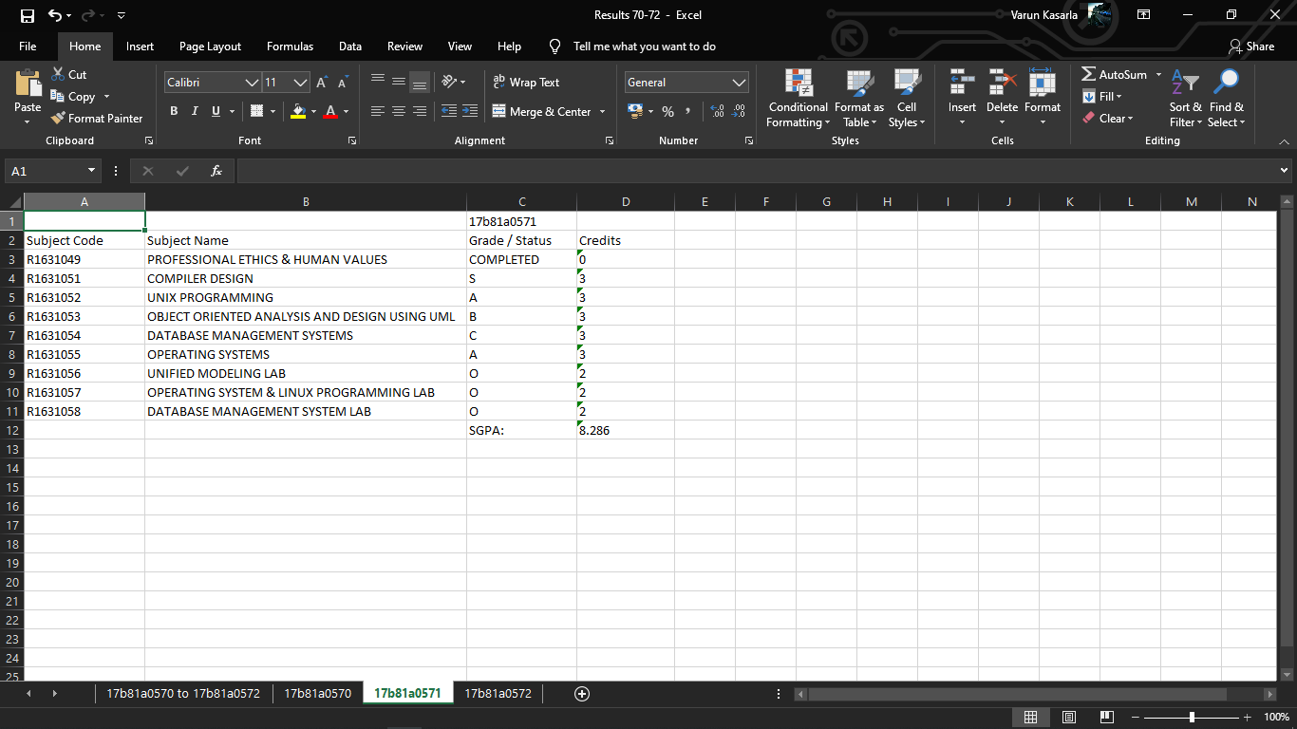

1. These are the screenshots of the Result Fetching from a PDF File.

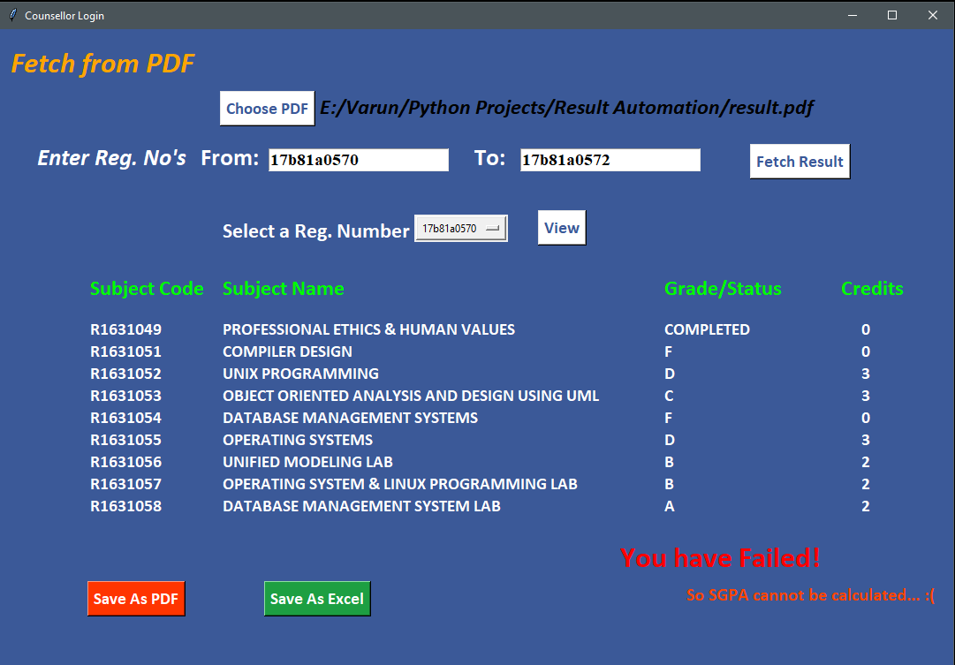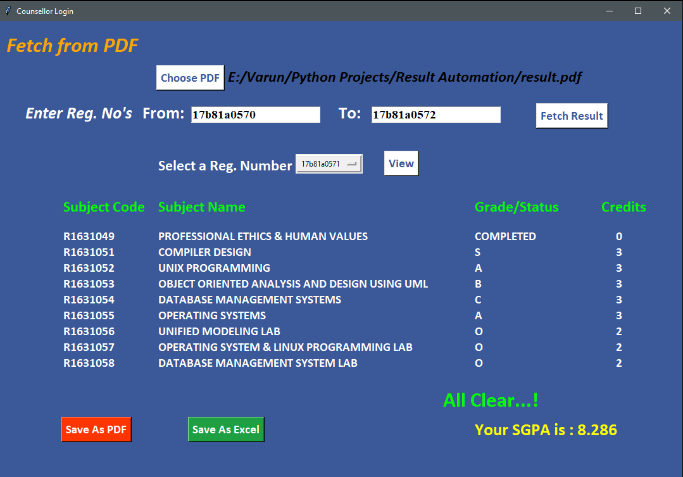

-***Thank You***-